How I communicate

I have a communication book.
The pages are colour-coded for each
thing I want to talk about.

I can select by picture to tell you what I am saying.

I prefer to talk using single words, but my speech is not very clear. My body language and facial expression may let you know how I feel.

Please listen carefully to me and encourage me to use my communication book as well.

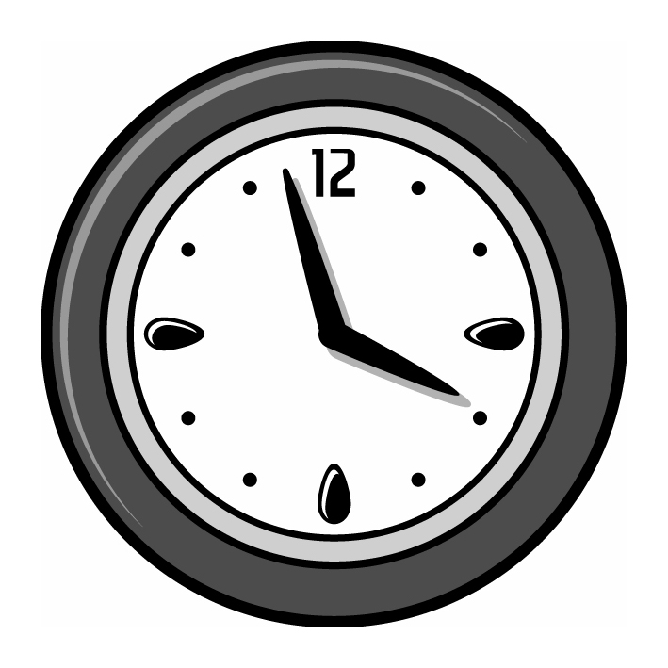
It helps me if you give me time to respond
to your questions and comments.

If I’m in pain, I hit my wheelchair arm
with my fist!

